Okereke Chidinma Blessing
18/MHS04/004
PHS 204- Endocrine Physiology
Assignment Submitted to Dr. Akintayo Christopher
Department of Human Nutrition and Dietetics
College of Medicine and Health Sciences

Discuss Contraception And Different Types With Details Of Any Five

Definition
Contraception (birth control) prevents pregnancy by interfering with the normal process of ovulation, fertilization, and implantation. There are different kinds of birth control that act at different points in the process.
Purpose
Every month a woman's body begins the process that can potentially lead to pregnancy. An egg (ovum) matures, the mucus that is secreted by the cervix (a cylindrical-shaped organ at the lower end of the uterus) changes to be more inviting to sperm, and the lining of the uterus grows in preparation for receiving a fertilized egg. Any woman who wants to prevent pregnancy must use a reliable form of birth control. Birth control (contraception) is designed to interfere with the normal process and prevent the pregnancy that could result. There are different kinds of birth control that act at different points in the process, from ovulation through fertilization to implantation. Each method has its own side effects and risks. Some methods are more reliable than others. Although there are many different types of birth control, they can be divided into a few groups based on how they work. These groups include:
Hormonal methods: These use medications (hormones) to prevent ovulation. Hormonal methods include birth control pills (oral contraceptives ), Depo Provera injections, and Norplant.
Barrier methods: These methods work by preventing the sperm from getting to and fertilizing the egg. Barrier methods include male condom and female condom, diaphragm, and cervical cap. The condom is the only form of birth control that also protects against sexually transmitted diseases, including human immunodeficiency virus (HIV) that causes acquired immune deficiency syndrome (AIDS).
Spermicides: These medications kill sperm on contact. Most spermicides contain nonoxynyl. Spermicides come in many different forms such as jelly, foam, tablets, and even a transparent film. All are placed in the vagina. Spermicides work best when they are used at the same time as a barrier method.
Intrauterine devices (IUDs): These devices are inserted into the uterus, where they stay from one to ten years. An IUD prevents the fertilized egg from implanting in the lining of the uterus and may have other effects as well.
Tubal ligation: This medical procedure is a permanent form of contraception for women. Each fallopian tube is either tied or burned closed. The sperm cannot reach the egg, and the egg cannot travel to the uterus.
Vasectomy: This medical procedure is the male form of sterilization and should be considered permanent. In vasectomy, the vas deferens, the tiny tubes that carry the sperm into the semen, are cut and tied off.

TYPES OF CONTRACEPTION

- THE CONDOM
The condom is the only form of contraception that protects against most STIs as well as preventing pregnancy. This method of contraception can be used on demand, is hormone free and can easily be carried. And it comes in male and female varieties. Male condoms are rolled onto an erect penis and act as a physical barrier, preventing sexual fluids from passing between people during sex. The female condom is placed into the vagina right before sex. Based on typical use, the female condom is not quite as effective as the male latex condom and it may take a little practice to get used to. Pros include: It is the best protection against STIs; can be used on demand; hormone free. Cons include: It can tear or come off during sex if not used properly; some people are allergic to latex condoms. Condoms are the only form of contraception that also protect against STIs.

- THE ORAL CONTRACEPTIVE PILL
It is s little tablet taken once a day. The oral contraceptive pill is very common. The combined pill contains estrogen and progestin and mini pill contains only one hormone, a progestin. The pill can have many benefits; however it is important for one to remember to take it on time. Pros of taking the pill include: Highly effective when used correctly; permits sexual spontaneity and does not interrupt sex; some pills may even reduce heavy and painful periods and/or may have a positive effect on acne. Cons include: Forgetting to take pill means it won’t be as effective; it can only be used by women; is not suitable for women who can't take estrogen-containing contraception; it does not protect against STIs. The pill is only available by getting a prescription from a medical professional. The oral contraceptive pill is taken once a day and is currently the most common contraception.

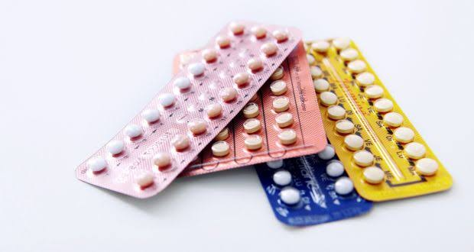
- INTRAUTERINE DEVICE (IUD)
It is a small, T-shaped device made material containing progesterone hormone or plastic and copper and is fitted inside a woman’s uterus by a trained healthcare provider. It's a long-acting and reversible method of contraception, which can stay in place for three to ten years, depending on the type. Some IUDs contain hormones that are gradually released to prevent pregnancy. The IUD can also be an effective emergency contraception if fitted by a healthcare professional within five days (120 hours) of having unprotected sex. IUDs containing coppers are 99% effective and the ones containing hormones are 99.8% effective, so one is about as protected as possibly can be by a contraceptive method. Cons include: Irregular bleeding and spotting occurs in the first six months of use; requires a trained healthcare provider for insertion and removal; does not protect against STIs. IUDs offer very effective protection against pregnancy.

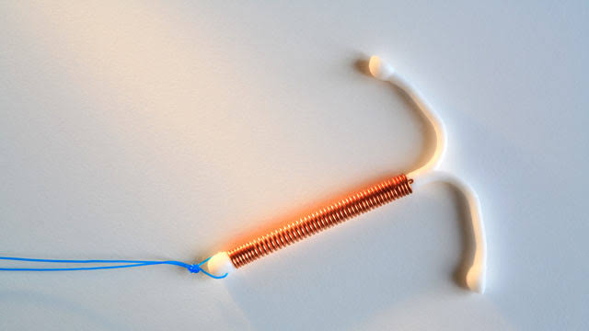

- THE CONTRACEPTIVE IMPLANT
In this method, a small, flexible rod is placed under the skin in a woman’s upper arm, releasing a form of the hormone progesterone. The hormone stops the ovary releasing the egg and thickens the cervical mucus making it difficult for sperm to enter the womb. The implant requires a small procedure using local anesthetic to fit and remove the rod and needs to be replaced after three years. Pros of the implant include: Highly effective; doesn’t interrupt sex; is a long-lasting, reversible contraceptive option. Cons include: Requires a trained healthcare provider for insertion and removal; sometimes there can be irregular bleeding initially; does not protect against STIs. Women can choose to use the implant as a long-term contraceptive method.

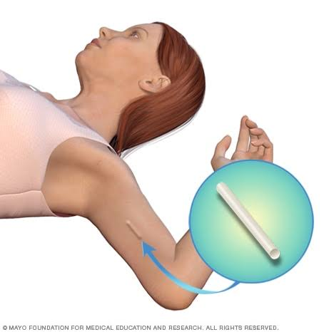

- CONTRACEPTIVE RING
This method consists of a flexible plastic ring constantly releasing hormones that is placed in the vagina by the woman. It stays in place for three weeks, and then it is removed, a week off is taken then another one is popped in again. The ring releases the hormones estrogen and progestagen. These are the same hormones used in the combined oral contraceptive pill, but at a lower dose. Pros include: one can insert and remove a vaginal ring themself; this contraceptive method has few side effects, allows control of periods and allows fertility to return quickly when the ring is removed. Cons include: It is not suitable for women who can't take estrogen-containing contraception; one needs to remember to replace it at the right time; does not protect against STIs. The contraceptive ring releases a lower dose of hormones to control a woman's ability to conceive than other contraceptive methods like the pill.
